Pass for level 19: 4IwIrekcuZlA9OsjOkoUtwU6lhokCPYs

Step 1:Login

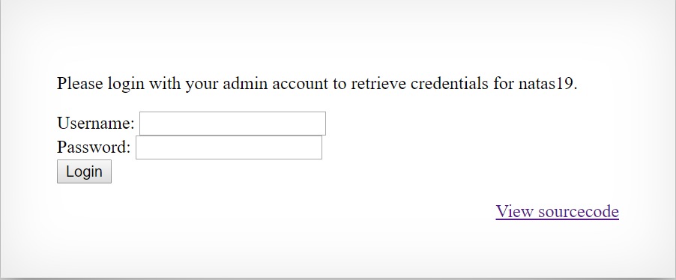

Step 2: View source code

We see interesting function in php code :

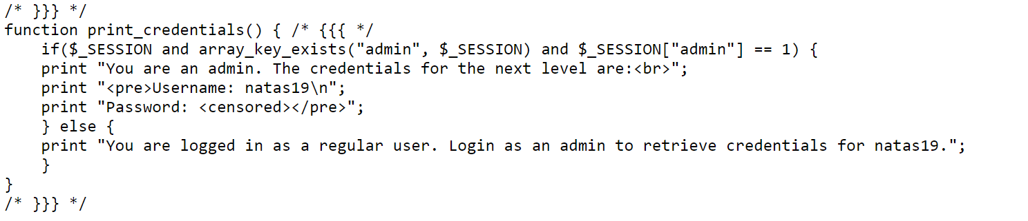

And some clues in Cookies because:

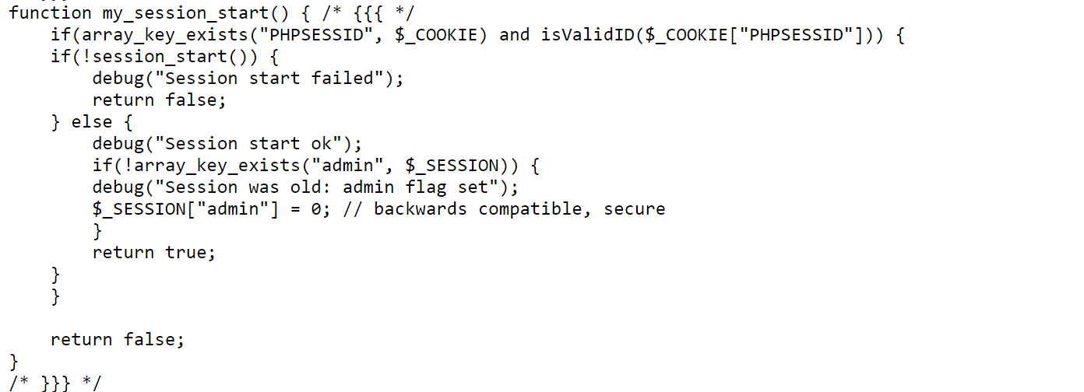

So probably we need to set the cookies['PHPSESSID'] to the actually admin id that in range of [1,640] and then we will se with ger request the password for natas 19

Step 3: Level19.py code – brute forcing.

